**Share Point**

<https://sharepoint.esds.co.in/Documents>

1. Click on the link

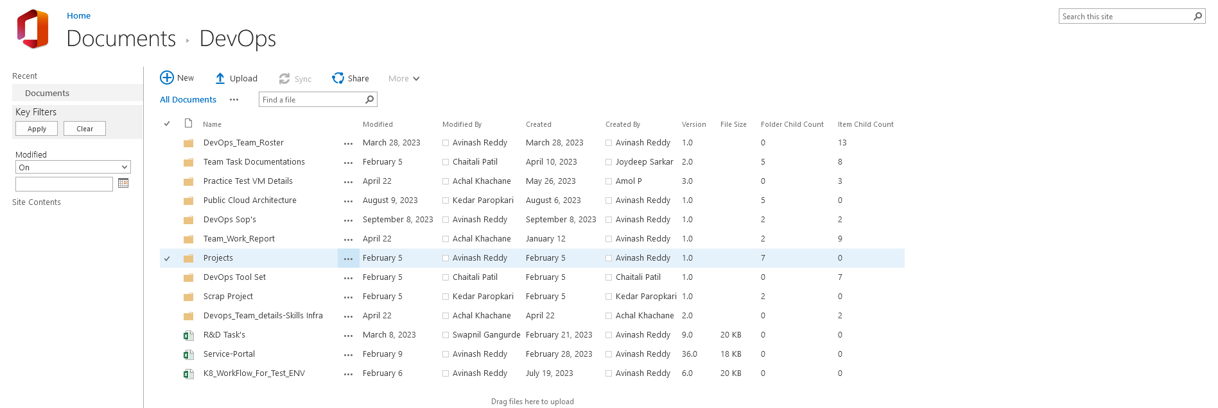

1. To Create new files

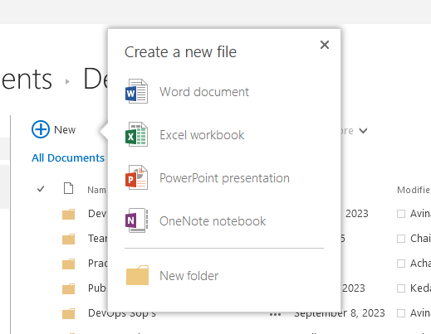

1. To Upload existing files from Local System

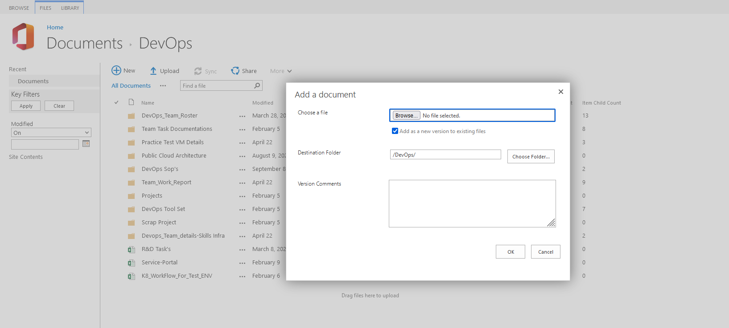

1. To Share selected document or folder > Invite people

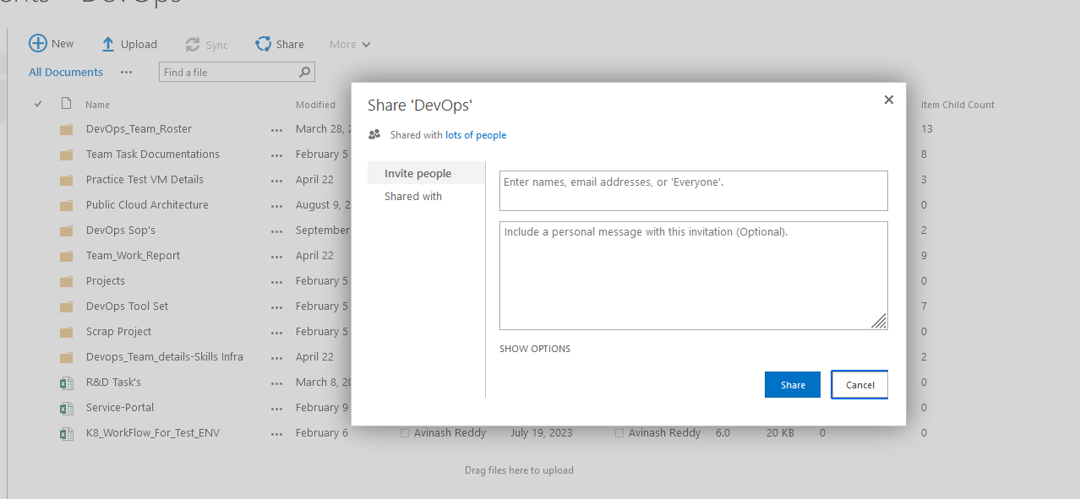

1. To share the document with link (Delete, Edit, Download in Local System, Version history)

